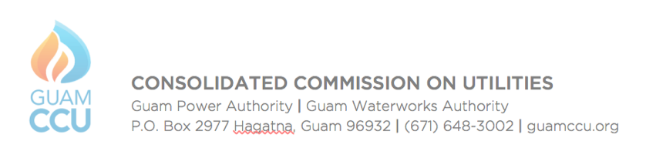
GUAM WATERWORKS AUTHORITY WORK SESSION
CCU Conference Room
4:30 p.m., Tuesday, April 20, 2021

AGENDA

- CALL TO ORDER

- ISSUES FOR DECISION
2.1 Authorizing Management of Guam Power Authority and Guam Waterworks Authority to Procure Merchant Services / GWA Resolution No. 15-FY2021 and GPA Resolution No. 2021-06
2.2 Authorizing Management of Guam Power Authority and Guam Waterworks Authority to Receive Payments from Guam Solid Waste Authority (GSWA) Customers at GPWA Facilities / GWA Resolution No. 17-FY2021 and GPA Resolution No. 2021-11
2.3 Approving the Guam Waterworks Authority Financial Plan Update for FY2022-FY2024 / Resolution No. 18-FY2021
2.4 Contract Approval for the Tai Road/S-13 and Canada-Toto Loop/Blas Street Waterline Replacement Project; GWA Project No. M19-001-BND / Resolution No. 19-FY2021
2.5 Creation of the Community Outreach Program Director Position for the Guam Waterworks Authority / Resolution No. 20-FY2021

- GM REPORT
3.1 GM Summary

- ISSUES FOR DISCUSSION

- OTHER DISCUSSION
5.1 CCU Rules Update

- DIVISION REPORTS
6.1 Communications
6.2 Compliance & Safety
6.3 Customer Service
6.4 Engineering
6.5 Finance
6.6 Operations

- ANNOUNCEMENTS
7.1 Next CCU Meetings: GPA Work Session: April 22; CCU Regular Monthly Mtg.: April 27

- ADJOURNMENT

